**Problem Statement:**

You have successfully cleared your fourth semester. In the fifth semester you will work with clauses and SET operators.

**Tasks To Be Performed:**

1. Arrange the ‘Orders’ dataset in decreasing order of amount.

**Snippet:**

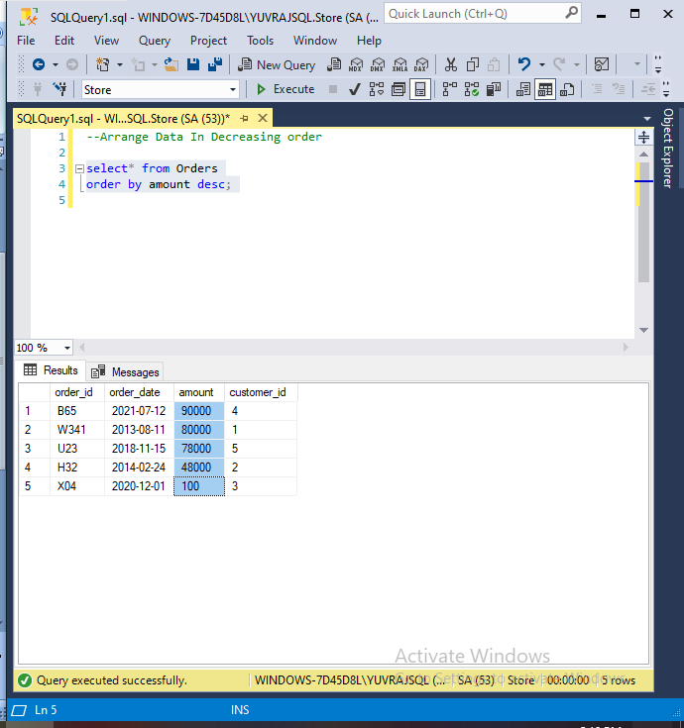

1. Create a table with the name ‘Employee_details1’ consisting of these columns: ‘Emp_id’, ‘Emp_name’, ‘Emp_salary’. Create another table with the name ‘Employee_details2’ consisting of the same columns as the first table.

**Snippet:**

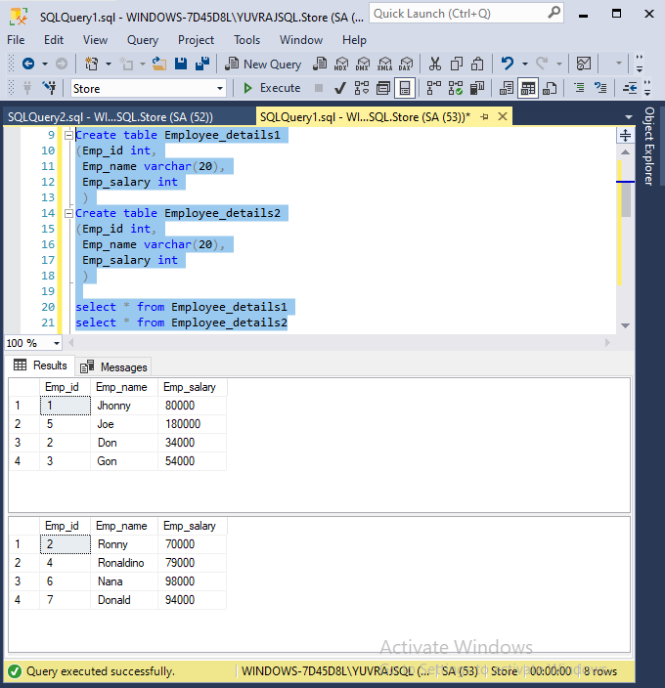

1. Apply the UNION operator on these two tables

**Snippet:**

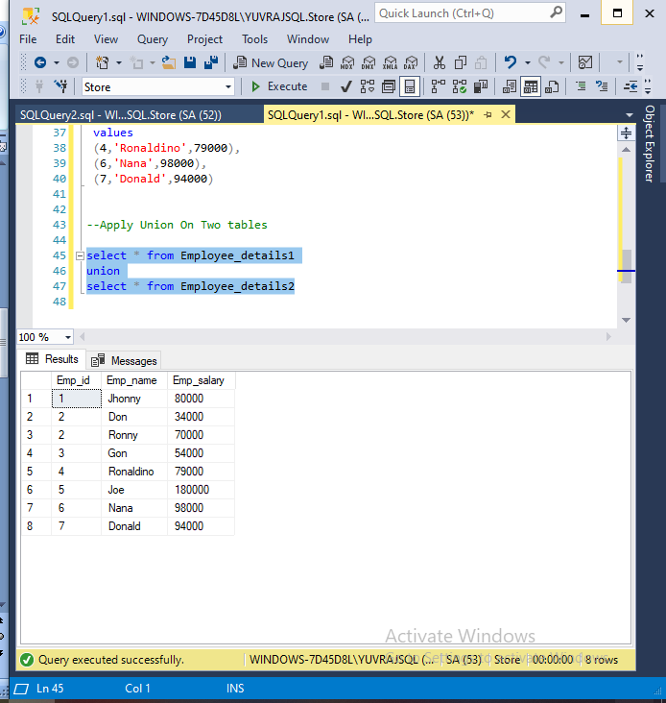

1. Apply the INTERSECT operator on these two tables

**Snippet:**

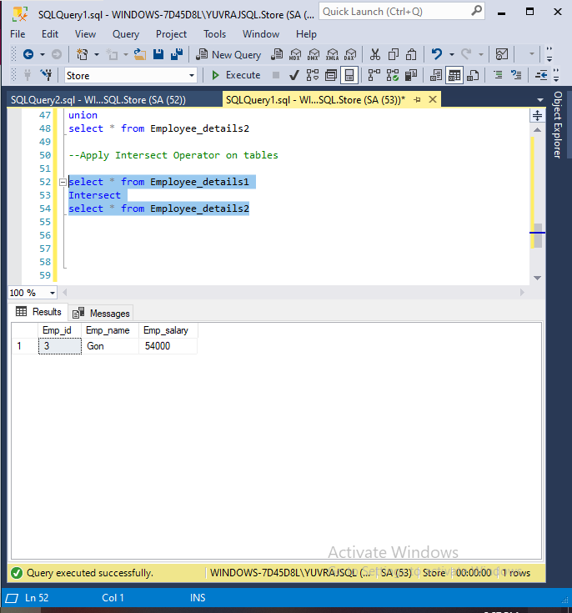

1. Apply the EXCEPT operator on these two tables

**Snippet:**

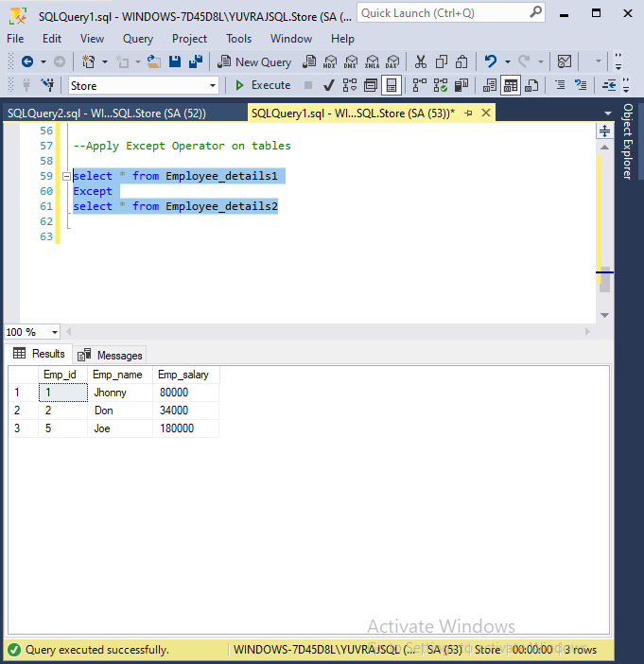

Script For Reference:

--Arrange Data In Decreasing order

select* from Orders

order by amount desc;

-- Create two tables with same parameters

Create table Employee_details1

(Emp_id int,

Emp_name varchar(20),

Emp_salary int

)

Create table Employee_details2

(Emp_id int,

Emp_name varchar(20),

Emp_salary int

)

select * from Employee_details1

select * from Employee_details2

insert into Employee_details1

(Emp_id,

Emp_name,

Emp_salary

)

values

(5,'Joe',180000),

(2,'Don',34000),

(3,'Gon',54000)

insert into Employee_details2

(Emp_id,

Emp_name,

Emp_salary

)

values

(3,'Gon',54000),

(4,'Ronaldino',79000),

(6,'Nana',98000),

(7,'Donald',94000)

--Apply Union Operator On Two tables

select * from Employee_details1

union

select * from Employee_details2

--Apply Intersect Operator on tables

select * from Employee_details1

Intersect

select * from Employee_details2

--Apply Except Operator on tables

select * from Employee_details1

Except

select * from Employee_details2